7520 Georgetown Road,
Indianapolis, IN 46268, USA

Asset Information  Serial #: 210011  Model #: TS-2300  Ship Date: | Account/Contact Information  Account Name: Manna Beverages & Ventures  Contact Name: Neil Johnson  Contact Phone: 470-622-9675  Contact Email: neil.johnson@westrock.com

Appointment Information
Service Resource: Aserota Wright
Start Date: 09/17/2024
End Date: 09/20/2024

Field Service Summary:
MODEL: TS-2300, BPTW-6000
SERIAL# 210011, 210012

Duravant Lifecycle Services proposes to provide one (1) technician to perform an equipment audit on Manna Beverages/ WestRock TS-2300, BPTW-6000 SN: 210011 and 210012.

The technician will assess the overall condition of the equipment for the purpose of determining any worn components affecting the reliability of the equipment, necessary requirements to bring the equipment back to “original OEM condition” and obsolete components and/or other functional upgrades necessary to run the most efficiently.

1. Within fifteen (15) business days of the completion of the audits, a written report detailing the equipment condition, component replacement costs and available functional upgrades will be sent.

Field Service Solution:

Field Service Date: 9/17/2024 - Tuesday.
Notes For The Day:
- 7:00pm - Travel to site.
- 9:00am - Arrived on site.
- Safety meeting.
- Audit Machine SN: 210011 - Machine inspection for worn parts.
- 5:00pm - Meeting
- Continue audit on machine SN: 210011
- 7:00pm - Departed site.
Field Service Date: 9/18/2024 - Wednesday.
Notes For The Day:
- 7:00pm - Arrived on site.
- Started Audit machine inspection SN210012 Bundler wrapper.
- Machine SN:210011 - Modified PLC program for the collator assembly, decreased Infeed conveyor speed to reduce back pressure on collator, Made adjustments to the blank tray sensor. Machine keeps coming up with: Detect Missing tray error message.
- Machine is now running good with these error messages.
- Continue Audit on Machine SN: 210012 bundler wrappers.
- 5:00pm - Meeting with customer.
- 7:00pm - Departed site
Field Service Date: 9/19/2024 - Thursday.
Notes For The Day:
- 7:00pm - Arrived on site.
- We are scheduled to modify the tray push lug conveyor to be centered with the tray forming lug conveyor.
- Wait for production to end.
- 9:00am - Production ended. We had 2 hours of downtime to do the work we were scheduled to do with the tray lug conveyor.
- After removing all the covers to get to the tray conveyor chain, we found out the work will take more than the time allowed to do the work on the conveyor.
- The modification for the conveyor will be scheduled for another time.

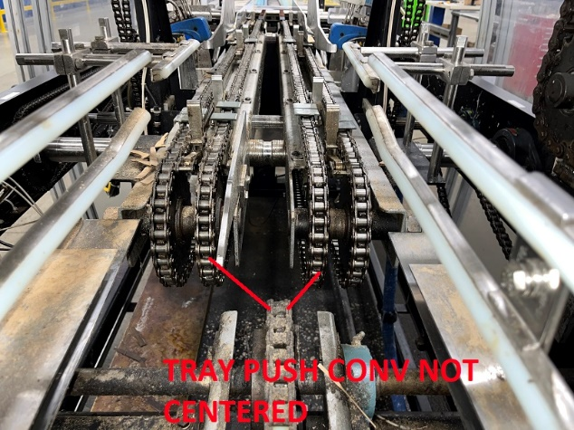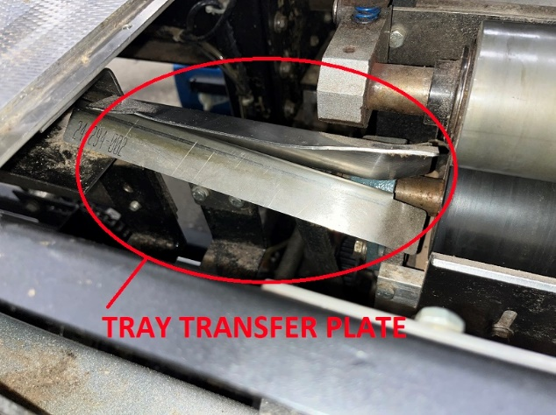

- 12:00pm - Production ready to start.
- I had a lot of issues during startup with the blank feed system. The blanks keep getting caught and stuck at the tray transfer plate. We had to modified and straightened the tray transfer plates to fix the problem.
- Also there were a lot of issues with the tray forming lug conveyor. The trays were getting squeezed after the glue units. The trays going into the forming lug chain conveyor were more hanging on one side the other side. We had to adjust the tray guides to center the tray in the forming conveyor to fix the problem.
- 10:30pm - Departed site.

Next Steps: No further action identified with customer agreement.

Field Service Images
Images

Work Order Line Item Information
Asset | Comments | Work Order Line Item Image
Arpac Brandpac
Arpac traystar

Thank you.

Aserota Wright.
Field Service Technician.

